# Building a Rock Paper and Scissor Project

Description

The Rock, Paper, Scissors game is a widely recognized and beloved game of chance and strategy. Its simplicity and accessibility make it a staple of childhood games and friendly competition. This project brings the classic Rock, Paper, Scissors game to life in the digital world, allowing you to challenge the computer or perhaps even a friend online .

The project is implemented using HTML, CSS, and JavaScript.

**Gameplay**

* Players (you and the computer) choose one of three symbols: Rock , Paper or Scissors.
* The game determines a winner based on the classic rules:
  + Rock crushes Scissors
  + Paper covers Rock
  + Scissors cut Paper
  + If both players choose the same symbol, it's a tie

Background

Rock, Paper, Scissors is a timeless game of chance and strategy that has transcended generations. Its simplicity and minimal resources required make it a universally recognized and accessible game. This project aims to bring this classic experience to the digital world, allowing users to play conveniently through a web browser

Project Objective

The objective of this project is to develop a web-based Rock, Paper, Scissors game using HTML, CSS, and JavaScript. This interactive application will allow users to play the classic game against the computer.

**Benefits**

This project serves as a practical learning tool for web development fundamentals.

Users will gain experience with:

* **HTML:** Creating the basic structure of the game's interface.
* **CSS:** Styling the game's elements for an engaging visual experience.
* **JavaScript:** Implementing core game logic, including user interaction, decision-making based on player and computer choices, and displaying results.
* Completing the project enhances users' portfolios, showcasing their ability to design and implement robust task management applications using relevant technologies.

Prerequisites

You should have VS Code or any other suitable IDE for programming and running the code.

### Technologies Used

* HTML 5
* CSS 3
* JavaScript

### Software and Tools Used

* Visual Studio Code
* Any Browser like Edge, Chrome, Safari

Project Structure

**HTML Structure**

The HTML page for the rock paper scissors game features a user-friendly interface with a top navigation bar that provides easy access to various sections of the page.

The main section of the page displays a captivating animated video showcasing the game, along with a heading and two buttons for "Play" and "Rules".

Below this section, there is a detailed description of the game, providing users with a better understanding of the gameplay. The page also features a second section similar to the first, followed by a footer that contains additional information or links. Overall, the page is designed to be visually appealing and easy to navigate, providing users with an engaging and informative experience.

Upon clicking the "Play" button, users are redirected to the game play page, where they can engage in a thrilling game of rock paper scissors against the computer. The page is divided into two main sections, with the top section featuring a prominent heading that displays the game's title, a "Rules" button that outlines the rules of the game, and a score counter that tracks the user's progress.

Below this section, a visually appealing grid displays three images of rock, paper, and scissors, each of which can be clicked to make a selection and play against the computer. The page's clean design and intuitive layout ensure that users can easily navigate and focus on the game, making for an immersive and enjoyable experience

**CSS Styling**

The Game's CSS sets the Baskervville font for the body, fills the viewport height, and centers content in containers. Headings are 24px, and Different Rgb Values are used for styling the background , all buttons have a hover effect. Winning , loose and tie the match gives red color messages and shows animation.

**Different RGB values used in this project**

* For background : rgb(0, 103, 105)
* For Text : rgb(230, 255, 148)

**JavaScript’s Logic**

The game's JavaScript manages player interaction and core logic. It captures user choices (rock, paper, scissors) through button clicks or key presses. A random computer choice is generated. The code then determines the winner based on classic rules, updates scores, and displays results dynamically.

**The game determines a winner based on the classic rules:**

* + Rock crushes Scissors
  + Paper covers Rock
  + Scissors cut Paper
  + If both players choose the same symbol, it's a tie

**UI Look**

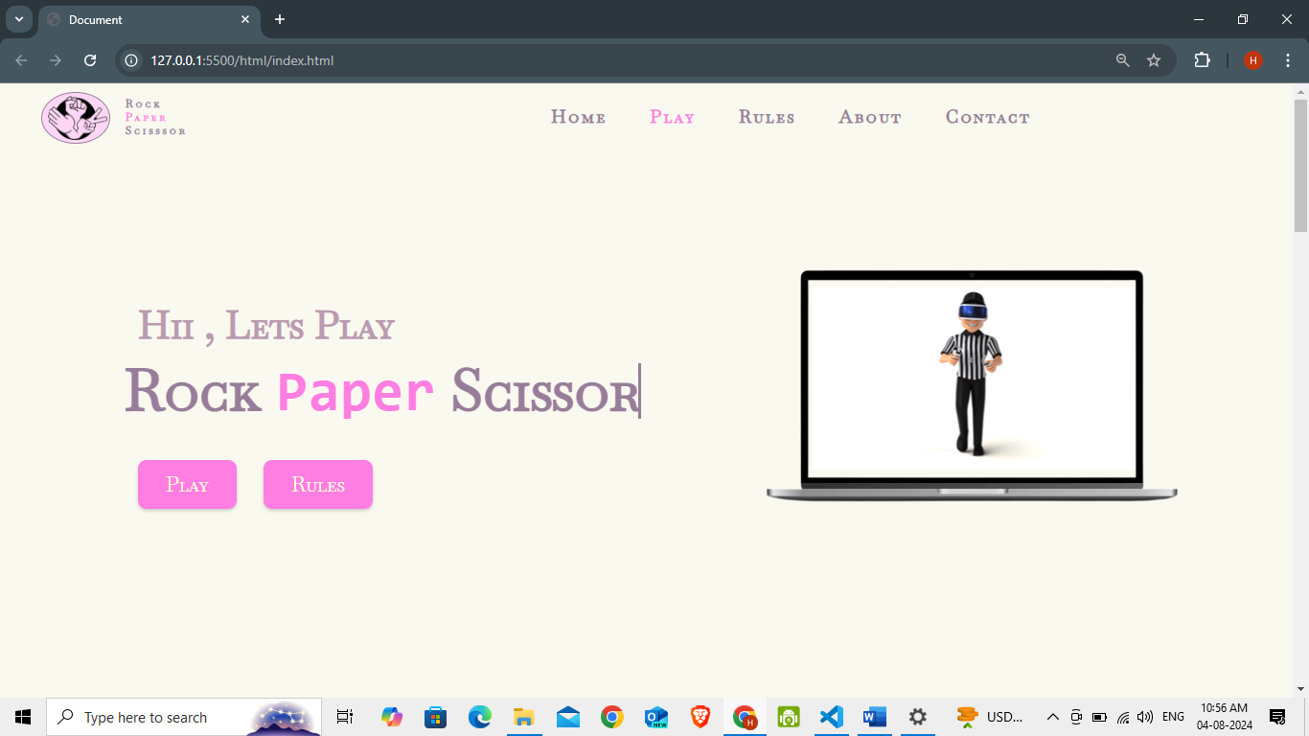Home page

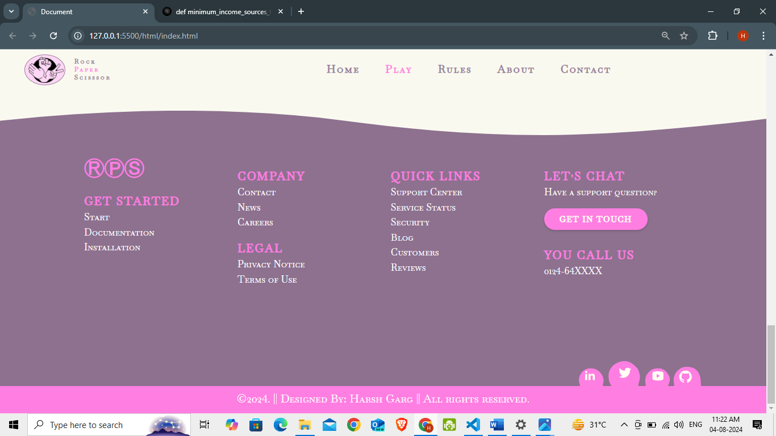Footer

Game page

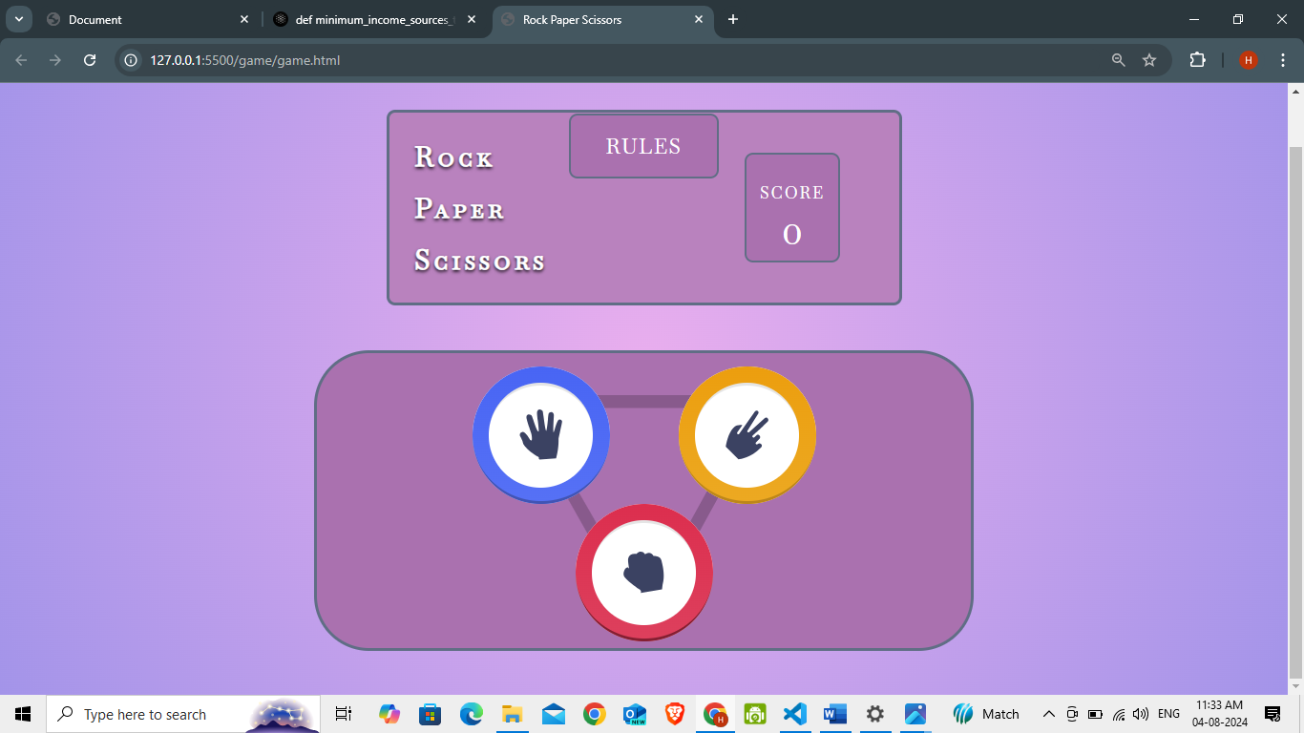

**Features**

* **Classic Gameplay:** Enjoy the familiar and beloved Rock, Paper, Scissors experience in a convenient digital format.
* **Challenge the Computer:** Test your luck and strategy against a virtual opponent.
* **Instant Results:** Get immediate feedback on each round, whether you emerge victorious, concede defeat, or land in a tie.
* **Lightweight and Accessible:** Play anytime, anywhere with a web browser. No downloads or installations required.

**Target Audience:**

* **Everyone:** Rock, Paper, Scissors is a universally recognized game suitable for players of all ages and skill levels.
* **Casual Gamers:** Enjoy a quick and light hearted way to pass the time and spark a friendly competition.
* **Kids:** Learn basic decision-making and develop hand-eye coordination in a fun and interactive environment.
* **Families and Friends:** Bond over a classic game that can be enjoyed by everyone, regardless of gaming experience.

### Project Working

To Start a game

When the user clicks on the "Play" button, a popup box appears asking for the user's name and the desired difficulty level (easy, medium, or hard). After entering this information and clicking the "Start Game" button, the user is redirected to the game play page.



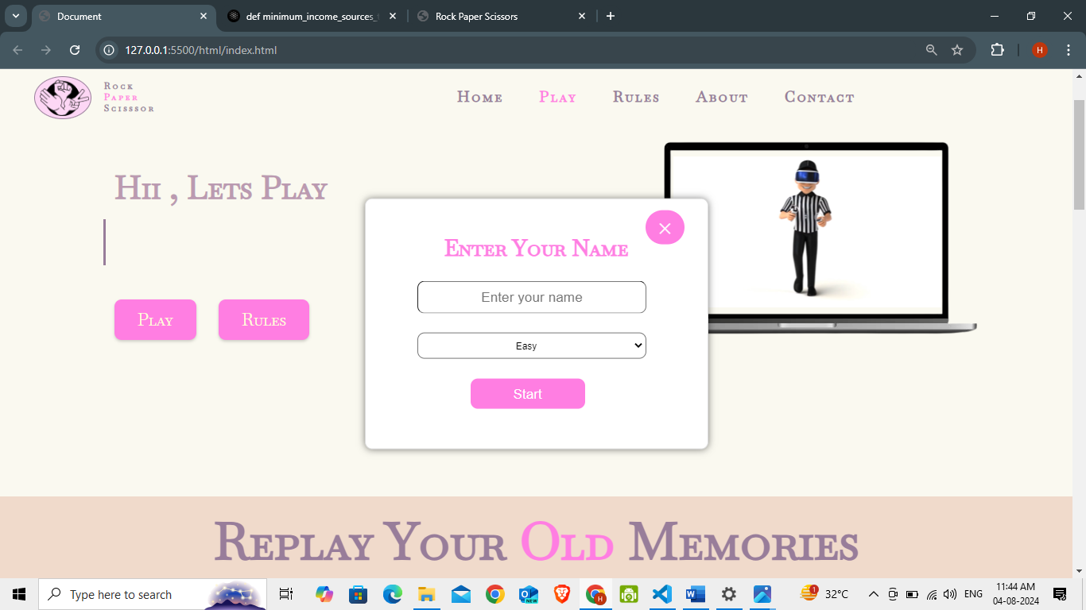

On Clicking "Play" button

a popup box appears

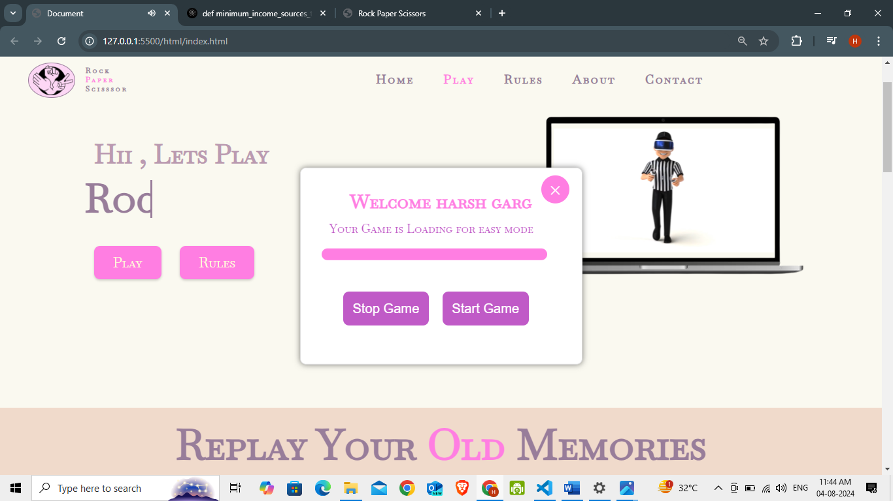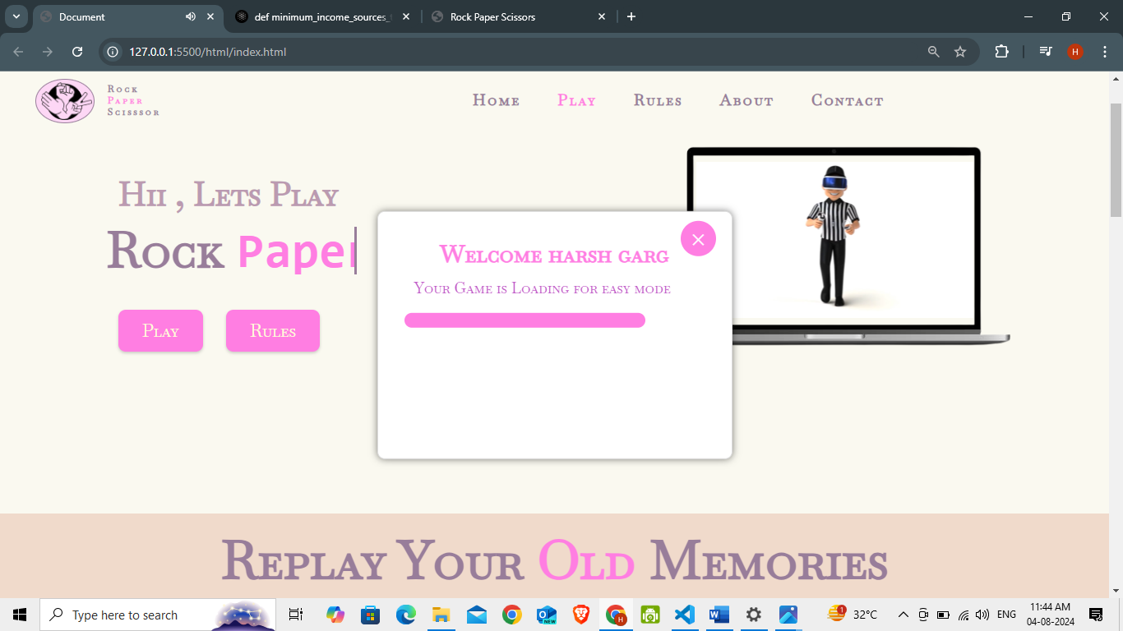When you click on start your game is loading

After loading

If You Click on Stop game , Your Game is Stopped and you come on home page   
If you Click on Start game , your game is Start and redirect to game page



Now you can play game by selecting one of the above images

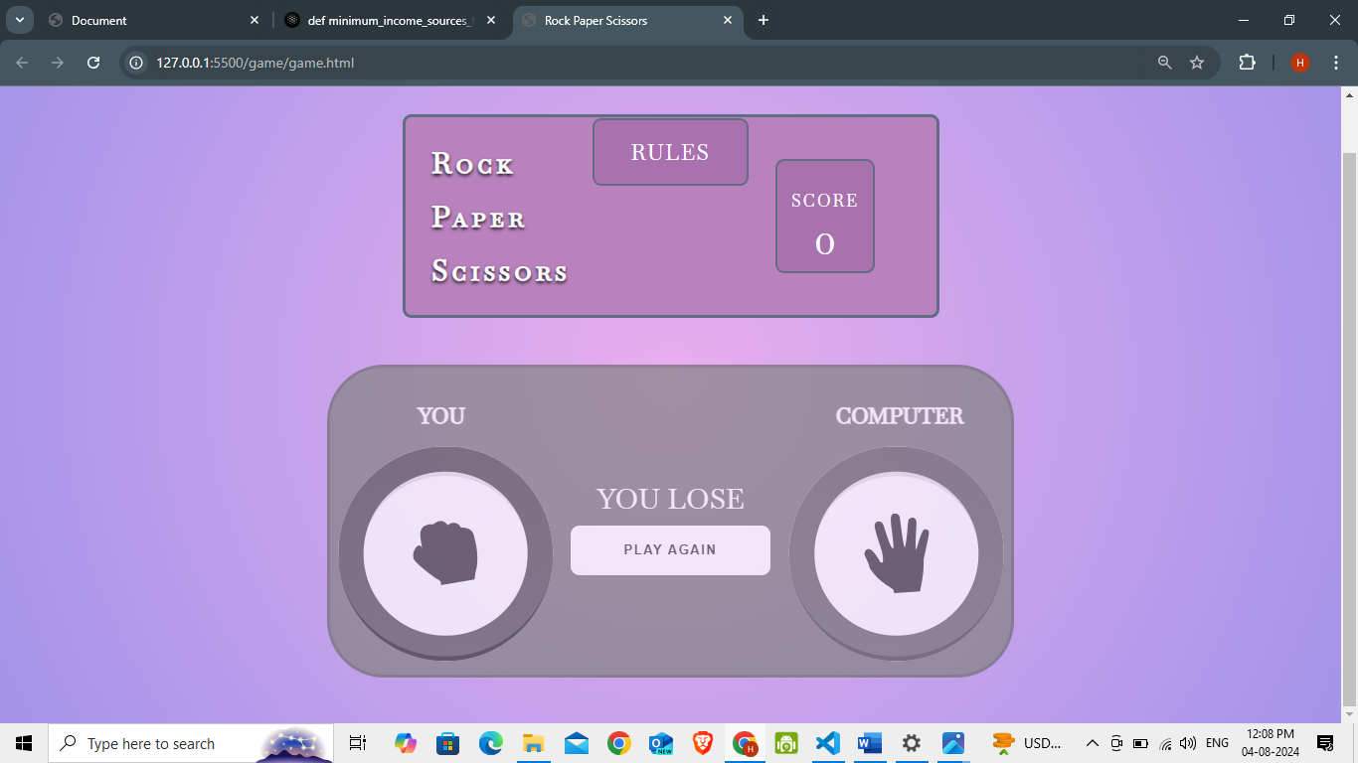**On Losing**

1 point is deducted

**On winning**

You Scored 1 Point

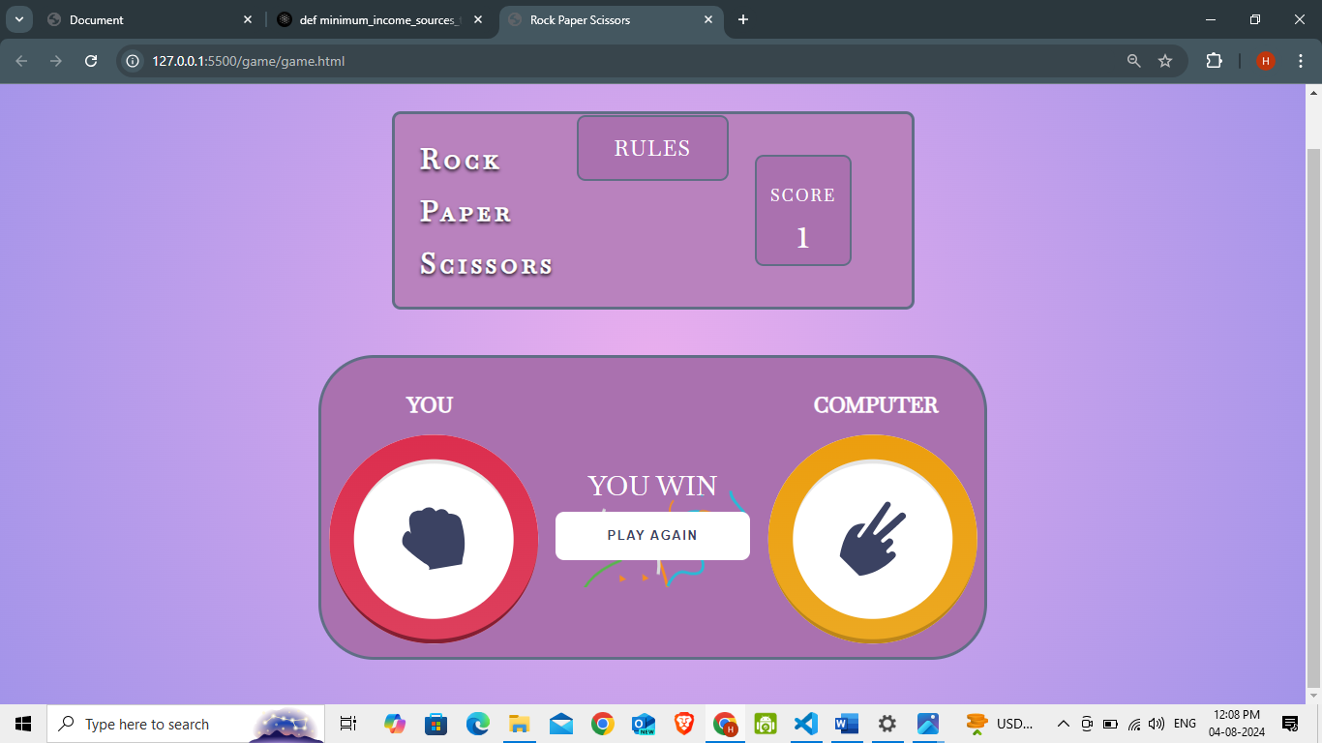

**On Draw**

Neither You scored nor lose a point

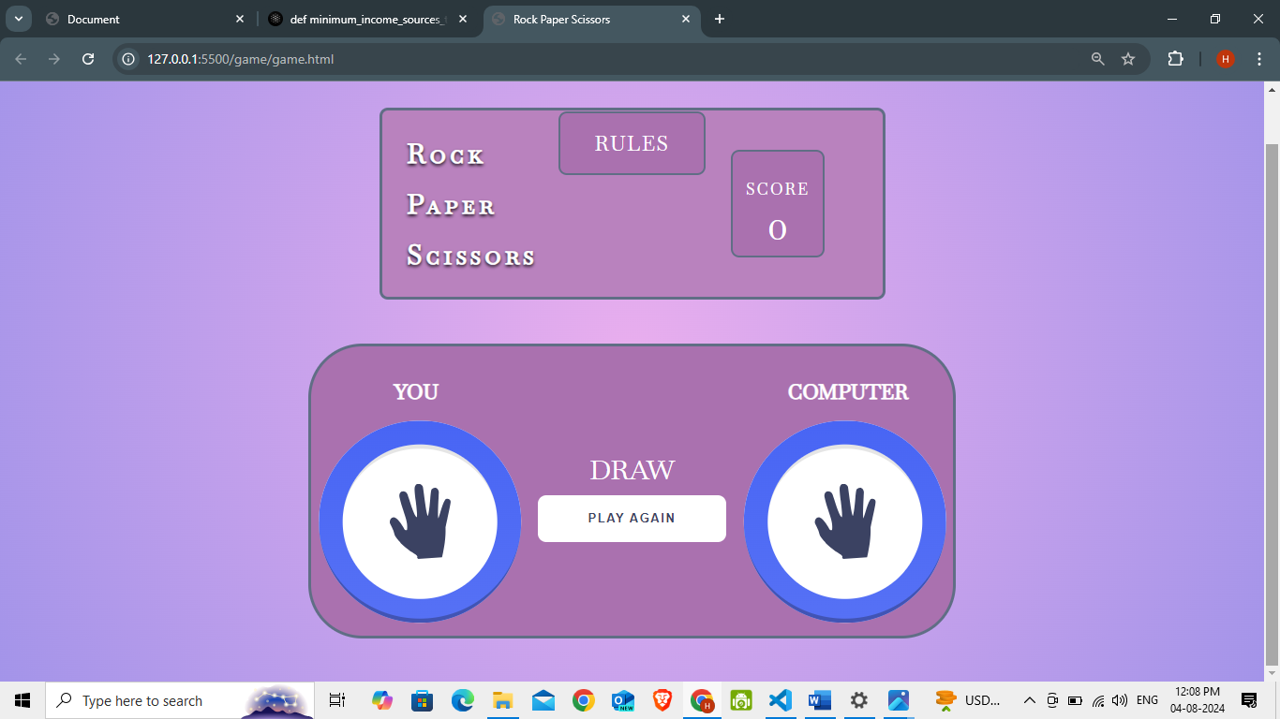

### Rules For The Game

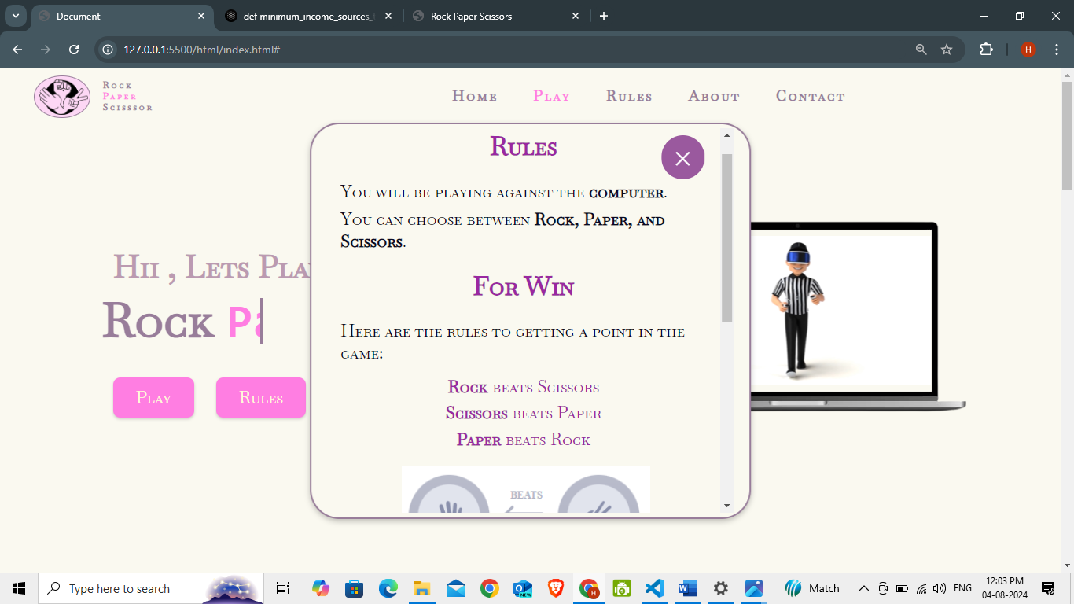

If you click on Rules button



Popup of rules

Rules

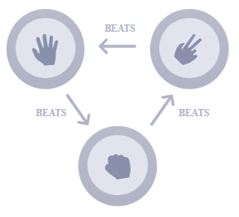

### Required code for above project

**HTML** For Play and Rules Button

<div class="but">

                <a id="play-button" class="button" target="_blank">Play</a>

                <a href="#" id="rules-btn" class="button">Rules</a>

            </div>

**CSS** For Play and Rules Button

.but {

    margin-left: 0;

    display: flex;

    align-items: flex-start;

}

.button {

    background-color: #FF7EE2;

    border: none;

    color: rgb(254, 251, 216);

    padding: .8rem 2rem;

    text-align: center;

    text-decoration: none;

    display: inline-block;

    border-radius: 10px;

    font-size: 1.5rem;

    font-weight: 500;

    margin: 3rem 1rem;

    cursor: pointer;

    box-shadow: rgba(0, 0, 0, 0.18) 0px 2px 4px;

}

.button:hover {

    background-color: rgb(247, 238, 232);

    color: #FF7EE2;

}

**HTML** For Popup box

   <!----------------------------------The popup box -------------------------->

    <div id="popup-box" style="display: none;">

        <span class="close-icon-popup" id="close-icon-popup">&times;</span>

        <div>

            <h2>Enter Your Name </h2>

        </div>

        <div> <input id="username" type="text" placeholder="Enter your name"></div>

        <div>

            <select id="mode">

                <option value="easy">Easy</option>

                <option value="moderate">Moderate</option>

                <option value="hard">Hard</option>

            </select>

        </div>

        <div><button id="start-button">Start</button></div>

    </div>

    <!---------------------------------- The progress bar------------------------------->

    <div id="progress-bar" style="display: none;">

        <span class="close-icon-bar" id="close-bar">&times;</span>

        <div class="name">

        </div>

        <div id="progress-bar-inner"></div>

        <audio id="loading-sound" src="../audio/music.mp3"></audio>

        <div id="game-controls" style="display: none;">

            <button onclick="location.reload()" id="stop-game">Stop Game</button>

            <a href="../game/game.html" target="_blank" rel="noopener noreferrer"><button id="start-game ">Start

                    Game</button></a>

        </div>

    </div>

**CSS** For Popup box

#popup-box {

    z-index: 1000;

    height: 22rem;

    width: 30rem;

    position: fixed;

    flex-direction: column;

    top: 50%;

    left: 50%;

    transform: translate(-50%, -50%);

    background-color: #fff;

    padding: 20px;

    border: 1px solid #ddd;

    border-radius: 10px;

    box-shadow: 0 0 10px rgba(0, 0, 0, 0.5);

    display: none;

    text-decoration: none;

}

#popup-box .close-icon-popup{

    position: absolute;

    top: 1rem;

    right: 2rem;

    font-size: 2.3rem;

    font-weight: 500;

    cursor: pointer;

    background-color:  #FF7EE2;

    border-radius: 2rem;

    padding: 0 1rem;

    color: #ffffff;

}

#popup-box .close-icon-popup:hover{

    background-color:#fa50d5

}

#popup-box div {

    margin: 1.7rem;

}

#popup-box div h2 {

    font-size: 2rem;

    text-align: center;

    color: #FF7EE2;

}

#popup-box div input {

    padding: .6rem;

    width: 20rem;

    margin-left: 1.6rem;

    text-align: center;

    border-radius: 10px;

    font-size: 1.2rem;

}

#popup-box div select {

    padding: .6rem;

    width: 20rem;

    margin-left: 1.6rem;

    text-align: center;

    border-radius: 10px;

}

#popup-box div button {

    padding: .6rem;

    width: 10rem;

    margin-left: 26%;

    text-align: center;

    border-radius: 10px;

    margin-top: 0;

    border: none;

    text-decoration: none;

    cursor: pointer;

    font-weight: 500;

    background-color: #FF7EE2;

    font-size: 1.2rem;

    color: rgb(255, 255, 255);

}

#popup-box div button:hover {

    background-color: #fa50d5;

    color: rgb(255, 255, 255);

}

**Javascript** For Popup box

const playButton = document.getElementById('play-button');

const popupBox = document.getElementById('popup-box');

const progressBar = document.getElementById('progress-bar');

const gameControls = document.getElementById('game-controls');

const usernameInput = document.getElementById('username');

const modeSelect = document.getElementById('mode');

const startButton = document.getElementById('start-button');

const startGameButton = document.getElementById('start-game');

const stopGameButton = document.getElementById('stop-game');

const progressBarInner = document.getElementById('progress-bar-inner');

const loadingSound = document.getElementById('loading-sound');

const closepopup = document.getElementById('close-icon-popup');

const closebar = document.getElementById('close-bar');

const divElement = document.getElementsByClassName('name')[0];

playButton.addEventListener('click', () => {

    popupBox.style.display = 'block';

});

startButton.addEventListener('click', () => {

    var username = usernameInput.value;

    const mode = modeSelect.value;

    if (usernameInput.value === "")

        alert("enter name ");

    else {

        const h2Element = document.createElement('h2');

        const para = document.createElement('p');

        h2Element.innerHTML = "Welcome " + username;

        divElement.appendChild(h2Element);

        localStorage.setItem('username', username);

        para.innerHTML = "Your Game is Loading for " + mode + " mode";

        divElement.appendChild(para);

        popupBox.style.display = 'none';

        progressBar.style.display = 'block';

        loadingSound.play();

        progressBarInner.style.width = '0%';

        setTimeout(() => {

            progressBarInner.style.width = '100%';

        }, 2000);

        setTimeout(() => {

            // progressBar.style.display = 'none';

            gameControls.style.display = 'block';

        }, 6000);

    }

});

closepopup.addEventListener('click', () => {

    popupBox.style.display = 'none';

  });

  closebar.addEventListener('click', () => {

    progressBar.style.display = 'none';

  });

  stopGameButton.addEventListener('click', () => {

    progressBar.style.display = 'none';

  });

**Logic** For Win , loose or draw a match

    if (userChoice === computerChoice) { //draw condition

        resultTextElement.textContent = 'Draw';

    }

    else if (

        (userChoice === gameChoicesArray[0] && computerChoice === gameChoicesArray[1]) ||

        (userChoice === gameChoicesArray[1] && computerChoice === gameChoicesArray[2]) ||

        (userChoice === gameChoicesArray[2] && computerChoice === gameChoicesArray[0])

    ) { //lose conditions

        resultTextElement.textContent = 'You lose';

        gameContentElement.classList.add('gameContent--isLost');

        if (score > 0) {

            scoreNumberElement.textContent = score - 1;

        }

    }

    else { //win condition

        resultTextElement.textContent = 'You win';

        setTimeout(() => player.load('https://assets10.lottiefiles.com/packages/lf20_aEFaHc.json'), 900);

        scoreNumberElement.textContent = score + 1;

    }

Project Challenges

**Validating User Input :** One of the initial challenges was validating user input to ensure that only valid game moves (rock, paper, or scissors) are accepted.

**The Logic of Victory:** Implementing the game logic to determine the winner of each round posed a challenge. Ensuring that the game correctly applies the rules of rock-paper-scissors to determine the winner, and updates the score accordingly, required thoughtful coding practices

**Raising the Stakes:** Implementing Difficulty Levels Implementing the different difficulty levels (easy, medium, hard) required adjusting the game's behavior to provide an appropriate level of challenge for the user.

**Keeping Score:** A Delicate Balance Accurately keeping track of the user's score and displaying it in real-time required careful consideration of state management and DOM manipulation. Ensuring that the score is updated correctly and displayed in a clear and concise manner posed a challenge

**Project Scope**

 The Rock Paper Scissors project aims to develop a simple yet engaging game application using HTML, CSS, and JavaScript. The project involves creating an intuitive user interface for playing the classic rock-paper-scissors game. Key features include user input fields, game logic implementation, scorekeeping, and dynamic game state updates.

**Conclusion**

The Rock Paper Scissors project demonstrates the implementation of a basic game application using HTML, CSS, and JavaScript. It provides users with a simple and engaging interface for playing the classic rock-paper-scissors game. Further enhancements could include features such as multiplayer support, game statistics, and AI-powered opponents.

**Future Enhancements**

 Future enhancements may include:

• Implementing multiplayer support for online gameplay.

• Adding game statistics and leaderboards to track player performance.

• Enhancing the AI-powered opponent to provide a more challenging gameplay experience.

• Improving UI/UX design for a more immersive user experience.

• Enabling customizable game themes and settings for a personalized experience.

**Acknowledgment**

We would like to thank everyone who helped build the Rock Paper Scissors project, which allowed us to create a fun and engaging game application. Your commitment and assistance have been vital throughout the project's life cycle.

Contact Us

You can always reach out to us if you need help with this project. For getting help email us at [harshgarg2110@gmail.com](mailto:harshgarg2110@gmail.com) or connect to our Discord’s **#support** channel.